The NYS 4-H Dog Program
is holding a Canine Costume Contest!

In an effort to keep our 4-H dog handlers challenged as we enter the long months of cold & snow, we would like to offer a Winter Canine Costume Class.

There will be two friendly competitions. The first will run from January 1st until January 31st. Another contest will be offered in February with different categories.

Youth must submit a photo of a dog in costume along with the age of the handler and category they are entering. Youth who do not have a dog but would like to participate may submit a photo of a stuffed animal.

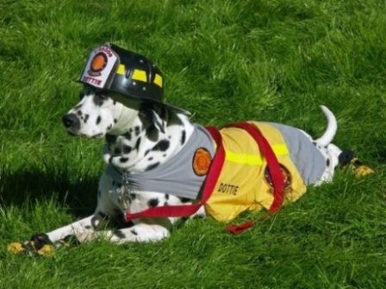
January categories include:

1) Covid-19 (costumes can be anything related to Covid-19 such as first responders, essential workers, etc.)

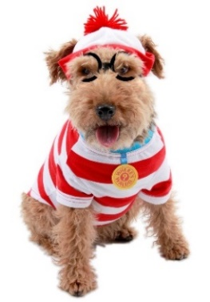
- Super Hero

- Zoo Animal

Age group (as of January 1st, 2021):

Cloverbud: Ages 5 7
Junior: Ages 8-12
Senior: Ages 13-19

Ribbons and Rosettes will be awarded!

For safety tips on how to dress your dog up safely, see the AKC article
How to Dress Up Your Dog Safely by Jordan Upmalis dated Oct. 6, 2020.

To register and submit your photo, visit:
https://cornell.ca1.qualtrics.com/jfe/form/SV_51I2sn74ngng70F

